Welcome to Paradise Lakes

The Bare Minimum You Need to Know
To make your stay as enjoyable as possible and avoid any unintended conflicts within our community, please read The Rules and Regulations Summary following this document.
Breaking any rules may result in fines, eviction and forfeiture of rent, and legal action!

Basic Information
You can contact us at ________________________ or _______________________
Wi fi username Password _______________________
PLCA (813) 948-6411

Safety
In case of emergency, call 911
For non-emergency Sherriff 727-847-8102
The fire extinguisher is located at ______________________________________________________________________
The first aid kit is located at ___________________________________________________________________________

Nearby Resorts
Paradise Lakes Resort
To see what’s happening at Paradise Resort during your stay, go to https://calendar.time.ly/cogmpxam/month
For current club membership rates, go to https://paradiselakesresort.com/daily-memberships.
Lake Como: 877-879-5253 www.lakecomonaturally.com

Caliente: 813-996-3700 www.calienteresorts.com

Wrap Up
Concerns or needs? Contact us and we will do our best to accommodate you.

Please take a few minutes to read our Welcome Packet to familiarize yourselves with Paradise Lakes Condo Association.

Please treat our condo as your own and enjoy your stay in Paradise!

Dare to be you!
Rules and Regulations Summary
Yours in Paradise
______________________________________________

Rules and Regulations
This is a quick reference and is not comprehensive. See the complete Rules and Regulations in our Welcome Book.
- PARADISE LAKES IS A NUDIST RESORT - Owners, renters, and occupants are expected to practice social nudism and shall behave in a manner consistent with the principles of social nudism, including the right of privacy of other residents and guests.
- SIDEWALKS - Sidewalks are for pedestrian use only. No motorcycles, bicycles, or golf carts allowed on sidewalks. Golf Carts are permitted on the Island Condos sidewalks (Bldgs. T, U, V).
- BICYCLES - Bicycles must be stored in bike racks or inside your unit.
- PETS
  - Renters are only allowed a maximum of one (1) pet per unit, with the unit owner’s written consent.
  - All pets must be on a 6-foot leash when not in your unit.
  - Pet owners are required to clean up after their pets.
  - Pet owners are encouraged to use designated dog walk areas (see map). The dog walk areas are currently located near the wooded area at the end of “P” bldg., and on the North side of the wall entrance to Phase 3 (Paradise Village).
  - Pets that cause a nuisance are not permitted.
  - Restricted Breeds are not permitted: 1. Pit Bulls & Staffordshire Terriers 2. Doberman Pinschers 3. Rottweilers 4. German Shepherds 5. Chows 6. Presa Canarios 7. Akitas 8. Wolf-hybrids 9. Mastiffs 10. Caucasian Mountain Dogs 11. Beaucerons 12. Boxers 13. American Bulldog
- NO FEEDING WILDLIFE- The potential danger of rabies in this county is real. Animals survive quite nicely without our help.
  - Alligators and Sandhill Cranes are protected under Florida State law. Anyone feeding or molesting these animals in any way is subject to penalties set forth by the State of Florida and Pasco County.
- NO NOISE SHOULD DISTURB OTHER RESIDENTS - This includes pets. Quiet hours are from 11 P.M. TO 8 A.M. except for Sunday until 10 am.
- NO PHOTOGRAPHY OR VIDEO RECORDING ON THE GROUNDS, INCLUDING DRONES - Unless permission has been granted by the subjects and the condominium office.
- NO ILLEGAL DRUGS - Paradise Lakes maintains a zero-tolerance drug policy.
- NO BARBECUES ON THE PORCHES - Use Fun Pads only. Fun Pads are social areas near most buildings.
- NO STORAGE ON PORCHES
- DUMPSTER - All garbage must be contained in securely tied trash bags. No household furniture, construction debris or appliances are to be placed in or near the dumpsters.
- SMOKING IN DESIGNATED AREAS ONLY – See map.
- BUSINESS ACTIVITIES - No visible business traffic or activities are allowed.
- SPEED LIMIT IS 10 MPH
- PARKING - Parking in appropriate designated areas only. Backing in is not permitted anywhere in PLCA.
- LIABILITY - A unit owner shall be liable to the Association for damage to any common elements caused by the unit owner(s), tenant(s) or guest(s).
- WEAPONS - No weapons of any kind are permitted in common areas.

Non- Emergency Numbers
Pasco County Sheriff's Office -727-847-8102
ER 24/7 Trinity - 813-953-3900 Address 1430 Dale Mabry Hwy
Fire Department - Lutz 813-929-1250

Laundry Room is located near the entrance to the RV park. See map.

Suggestions to help you develop your own page

Shopping
Publix - 15151 N Dale Mabry Hwy,
Walmart -1575 Land o Lakes Blvd
Target-1040 Dale Mabry Hwy
Big Lots -2414 Land O Lakes Blvd

Stores are all within a 2-mile radius from Paradise Lakes

Thoughts specific to owners or properties
This is a non-smoking/vaping unit. Evidence of smoking/vaping will result in a $250 cleaning charge.
TV streaming account information
Specific appliance operation, for example, tips on using the microwave (especially if it is also convection, etc.), Washer/dryer, range
Check in 3:00 Pm Check out 11:00 AM
Gate card location. Cost if lost.
- Please don’t take any Bath towels to the pool area. We have provided you with beach towels for your use. Return all beach towels to the unit.
- If you open any doors, sliding glass doors or windows, please turn the A/C off and please close them if you leave the condo. DO NOT LEAVE THEM OPEN.
- Please DO NOT sit or lay on any furniture if you have suntan lotion, oil or bronzer on. PLEASE, shower first.
- If sitting in the nude, please use the towels provided to cover the area you are sitting on.
- Please report any damages or equipment malfunctions immediately so we may address them.
- When checking out, please return the gate card to the hook and lock the door behind you.
- Please do not leave any remotes to the fans outside on the lanai/screened porch.
- Before you leave, please leave all wet towels in the bathtub/shower, not on the bed or furniture.
- Please bag your trash and take to the dumpster. Locations are on the map in the welcome packet.

Thank you for staying with us at Paradise Lakes!

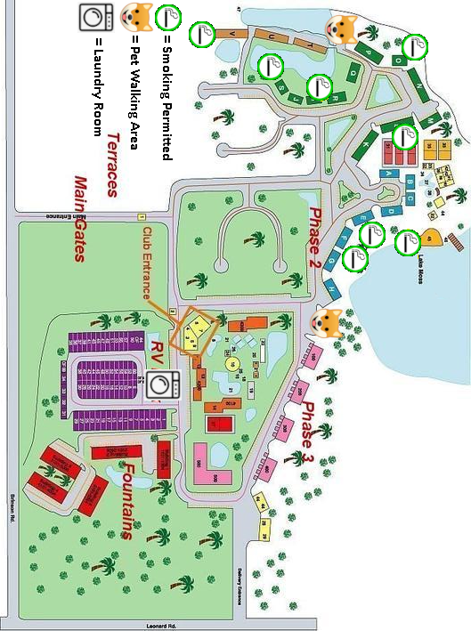

Destinations and Attractions
ZooTampa at Lowry Park – www.zootampa.org
Seminole Hard Rock Casino - 5223 N Orient Road, Tampa FL 33610
State Parks - https://www.floridastateparks.org/
Beaches - https://www.tripadvisor.com/Attractions-g28930-Activities-c61-t52-Florida.html
Nude Beaches - https://www.theworldandthensome.com/top-10-best-nude-beaches-in-florida-with-map/
Tampa Aquarium - https://flaquarium.org

Busch Gardens – A nice cross between an amusement park, zoo, and live entertainment. https://buschgardens.com/tampa/
Tarpon Springs – An old Greek sponge diving port. Lots of shopping and specialty restaurants. Boat tours. www.visitflorida.com/en-us/cities/tarpon-springs.html
Ybor City – A unique Old Town entertainment district. https://yborcityonline.com/
Lake Como – Nudist resort right behind us. You can get a 2 hour dinner pass and even arrange for a tour.
See the manatees - www.visitflorida.com/en-us/things-to-do/outdoors-nature/places-to-see-swim-florida-manatees.html
St Augustine – oldest town in the US. www.floridashistoriccoast.com/?msclkid=7b0749a60abb1843edd629a1015f77fe&utm_source=bing&utm_medium=cpc&utm_campaign=MI%20Florida%20Historic%20Coast%20Brand&utm_term=st%20augustine%20florida&utm_content=Brand%20City%20(exact)
Clearwater Beach – One of the top 5 beaches in the country - www.visitflorida.com/en-us/cities/clearwater-beach.html
Solomon’s Castle – A unique building and museum – all made from recycled materials. http://solomonscastle.com

For more info visittampabay.com

